import heapq

class Node:
def __init__(self, position, parent=None):
self.position = position
self.parent = parent
self.g = 0 # Distance from start node
self.h = 0 # Heuristic (estimated cost to end)
self.f = 0 # Total cost

def __lt__(self, other):
return self.f < other.f

def heuristic(a, b):
# Manhattan distance
return abs(a[0] - b[0]) + abs(a[1] - b[1])

def astar(grid, start, end):
open_list = []
closed_set = set()
start_node = Node(start)
end_node = Node(end)
heapq.heappush(open_list, start_node)

while open_list:
current_node = heapq.heappop(open_list)
closed_set.add(current_node.position)

# Goal check
if current_node.position == end_node.position:
path = []
while current_node:
path.append(current_node.position)
current_node = current_node.parent
return path[::-1] # Return reversed path

# Explore neighbors
x, y = current_node.position
neighbors = [(x + dx, y + dy) for dx, dy in
[(-1, 0), (1, 0), (0, -1), (0, 1)]]

for nx, ny in neighbors:
if 0 <= nx < len(grid) and 0 <= ny < len(grid[0]) and grid[nx][ny] == 0:
neighbor_pos = (nx, ny)
if neighbor_pos in closed_set:
continue

neighbor = Node(neighbor_pos, current_node)
neighbor.g = current_node.g + 1
neighbor.h = heuristic(neighbor_pos, end_node.position)
neighbor.f = neighbor.g + neighbor.h

if any(open_node.position == neighbor_pos and open_node.f <= neighbor.f for open_node in open_list):
continue

heapq.heappush(open_list, neighbor)

return None # No path found

# Example grid: 0 = free, 1 = obstacle
grid = [
[0, 1, 0, 0, 0],
[0, 1, 0, 1, 0],
[0, 0, 0, 1, 0],
[1, 1, 0, 0, 0],
[0, 0, 0, 1, 0]
]

start = (0, 0)
end = (4, 4)

path = astar(grid, start, end)
print("Path found:", path)

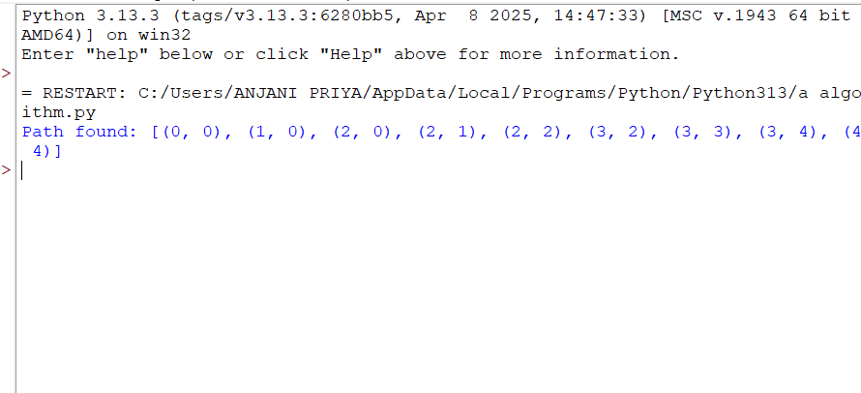
8

